

*Monitoring Student Performance in Learning and Curriculum*

By

AHMAD NASYRAN BIN AMRAN

AM1909006036

A project proposal

Submitted to

Ms SHUHADAH OTHMAN

Faculty of Computing & Multimedia Kolej Universiti Poly- Tech MARA

1120

**Contents**

Table of Contents

1. Introduction 2

2. Problem Statement 3

1. Data redundant and incorrect data if written by hand 3

2. Student results are not reused after students have known their exam results. 3

3. Wasting time in managing data 3

3. Problem Objective 3

1. To develop an application that can automatically calculate graph. 3

2. To develop an application that can teach teachers' skills in monitoring student learning. 3

4. Project Scope 4

4.1 System Scope 4

4.2 User Scope 4

5.0 Target User 4

6. Hardware Requirements 5

6.1 Software Requirement 5

6.2 Hardware Requirement 5

7.0Methodology 6

8. Gantt Chart 7

9.Conclusion 8

a. References 9

# Introduction

Monitoring Student Performance in Learning and Curriculum App (Mobile Application) is an application that is provided for monitoring of student learning progress. What does "monitoring student learning" involve? This app defines to monitoring as keeping watch over, supervising and also gives another more specific meaning to scrutinize or check systematically with a view to collecting certain specified categories of data. As the term is used in educational settings, monitoring takes in both these meanings and is closely connected with the related functions of record keeping, reporting, and decision making.

How does it show student performance and what data will be used? In this app, we will use student results throughout the year and curriculum results. Both results will be mixed to make a performance statistic such as percentage, graph (Line Graph, Bar Chart) in various forms of categories either a comparison between subject to subject or a comparison of new exam results to old exams result. With the result, can be used to see the achievement of the student to the next learning center (University, High Performance School) with the requirement of the result.

Both users, such as Teacher (Admin) and Student can be used to view the data to make research and make improvements in student result progression. So, what is the specific purpose of these two users in the action of this app? For teachers, they are monitoring to keep track of student learning for purposes of making instructional decisions and providing feedback to students on their progress. Teacher (Admin) also reviewing student performance data collected and recorded and using these data to make needed adjustments in instruction. Defined this way, monitoring obviously includes many kinds of activities especially with monitoring students' behavior. And it provides only cursory information on such matters as teacher training in monitoring and assessment practices or the processes teachers follow in putting monitoring information to use. Instead, the focus here is classroom-level monitoring of student learning progress and what research says about the relationships between such monitoring and the student outcomes of achievement, attitudes and social behavior. For students, they can see their records such as exam results and curriculum, and can even see the results with various forms of graphs. With the form of graphs students can analyze the comparison of exam performance more clearly. In addition, with the data students can see the minimum data requirements such as for the admission of students to universities or high-level schools. Students to be used are only for form 3,4,5 students because they are important students in the use and purpose of this app was created.

# Problem Statement

### Data redundant and incorrect data if written by hand

Too many papers to fill in student data that makes teachers make mistakes and messy to sequencing data.

### Student results are not reused after students have known their exam results.

Students will not see all their previous results to make comparisons or improvements for their learning. The result data is rubbish after the students know after their results.

### Wasting time in managing data

too much management such as collecting student data on paper, sorting files etc. causes slow management

# Problem Objective

### To develop an application that can automatically calculate graph.

This is to provide a tool that can digitally calculate the exam result dan curriculum result. Students are able to see benchmark performance in percentage and statistic graph.

### To develop an application that can teach teachers' skills in monitoring student learning.

Given the strong connection between teachers' monitoring of students' learning progress and those students' academic performance, it would be ideal if teachers received thorough training in monitoring and were highly skilled in classroom monitoring practices.

* 1. **To develop an application that can control the student outcomes of achievement, attitudes and social behavior.**

With the existence of this student app, Students become more aware of their own performance and activities. With this can control their behavior better and can improve their learning in school

# Project Scope

## System Scope

The mobile application will have a few features that will provide the greatest possible experience for the user. The login interface, which will allow users to enter the mobile app, is one of the elements that will be included in the mobile app. This system provides their profile after logging in. Students have a page that contains their data in the form of statistics, teachers can see the student data as well, but they have additional can manage and store student data.

## User Scope

There are 2 users that will use for this application, admin (teacher) and student. Teacher (Admin) who monitors the student performance and managing data. The student can view their result in various form of graph.

# 5.0 Target User

1. Teacher (Admin)

* The teacher is the user who will manage the student data of examination results and co-curricular results. They are also reviewing dan monitoring student performance data. It also training teacher in monitoring and assessment practices or the processes teachers follow in putting monitoring information to use. Teacher also questioning students during classroom discussions to check their understanding of their performance being taught.

1. Student

Student can access into our mobile application. The first thing that they need to do is login into the system. They can see their result in various form of statistic graph such as line graph and bar graph, also they can see their performance in percentage by result of examination and cocurricular. This mobile application can be used student form 3,4 and 5. We targeted this range of age because they are the important student who are going to next step to continue studying in high school and university.

# Hardware Requirements

## 6.1 Software Requirement

1. Ionic Framework
2. Angular

## 6.2 Hardware Requirement

* **Processor:** Minimum of 1GHz
* **Memory (RAM):** Minimum of 2GB RAM
* **Monitor Resolution:** 1024 X 768
* **Hard Drive:** Minimum of 20GB
* **Internet Connection:** 4Mbps or higher
* **Computer:** DELL Lenovo Inspiron 13 5000
  + **Processor:** Celeron Dual Core
  + **Memory (RAM):** 8GB RAM
  + **Display Resolution:** 1920 x 1080 Pixels
  + **Hard Disk:** 128GB

# 7.0Methodology

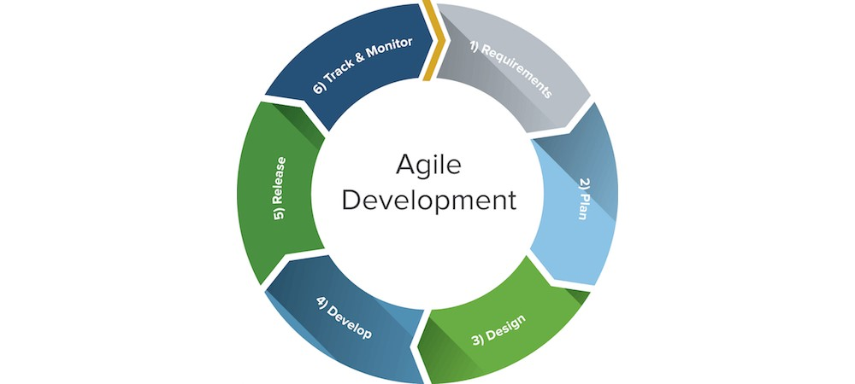

**Figure 1 Shows the Agile Methodology**

The methodology for this mobile application is Agile Methodology. The main reason for this methodology to be chosen is because it can be breaks into several stages and the improvement is done on every iteration. Using this Agile approach, we can get what the user actually wants for their mobile application.

# Gantt Chart

|  |  |  |  |  |  |  |  |  |  |  |  |  |  |
| --- | --- | --- | --- | --- | --- | --- | --- | --- | --- | --- | --- | --- | --- |
| **Project Schedule** | **W 1** | **W 2** | **W 3** | **W 4** | **W 5** | **W 6** | **W 7** | **W 8** | **W 9** | **W1 0** | **W1 1** | **W1 2** | **W1 3** |
| Information gathering |  |  |  |  |  |  |  |  |  |  |  |  |  |
| Requirem ents  & Analysis |  |  |  |  |  |  |  |  |  |  |  |  |  |
| Methodolo gy |  |  |  |  |  |  |  |  |  |  |  |  |  |
| Design |  |  |  |  |  |  |  |  |  |  |  |  |  |
| Coding & Programmi ng |  |  |  |  |  |  |  |  |  |  |  |  |  |
| Testing |  |  |  |  |  |  |  |  |  |  |  |  |  |
| Live |  |  |  |  |  |  |  |  |  |  |  |  |  |

# 9.Conclusion

The title of this project is Monitoring Student Performance in Learning and Curriculum. This is a mobile application that is used by the students and teachers. This application is an educational application where it enables the students to easily view their result and performance. To improving their learning better, this application provides better comparison with their result with graph. The statistic will help students to have a better understanding of the lessons and help students to prepare for their next examinations and their future plan of the study place. Teacher also can learn in monitoring and caring in terms of student affairs. I hope my application can be developed with design and meet user’s requirement that can attract attention. I really hope this can be useful to student or anyone that uses it and give satisfaction with the app.

# References

1. *monitoring-student-learning*. (1998). Educationnorthwest. https://educationnorthwest.org/sites/default/files/monitoring-student-learning.pdf
2. *Research Matters / How Student Progress Monitoring Improves Instruction*. (2021, June 29). ASCD. https://www.ascd.org/el/articles/how-student-progress-monitoring-improves-instruction
3. Teach Starter. (2019, July 19). *4 Benefits of Monitoring Student Progress in the Classroom*. https://www.teachstarter.com/au/blog/4-benefits-monitoring-student-progress-classroom/